Minor Project (BTCS607N) Weekly Progress Report (Week-4)
Project Title: Vaari - Crop Water Footprint Information App
Phase 2 — Object-Oriented Analysis
Goal: Model the dynamic flow of the system and show how the Vaari application responds to user actions using an activity diagram.
1. Introduction
- Week 4 focuses on dynamic analysis of the Vaari application.
- The purpose of this week is to show the sequence of activities that happen when a user searches for a crop and views its water footprint.
- This is represented using an activity diagram.
2. Activity Diagram
- The activity diagram describes the flow of actions inside the Vaari system.
- It starts with the user entering a crop name, followed by search processing, data retrieval, result display, and viewing the water footprint information.
- Decision points can be used if the crop is found or not found.
- The diagram may also show how the user can view search history or change language after the main search flow.

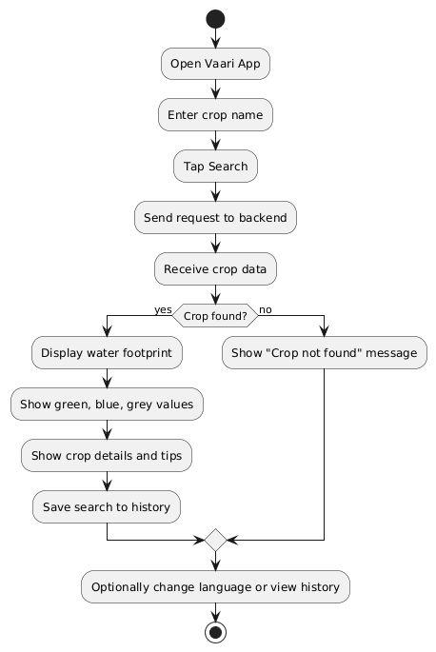
3. Main Flow Covered
- User opens the app.
- User enters crop name.
- System searches crop data.
- System retrieves water footprint values.
- System displays the result and related details.
- If no crop is found, an error message is shown.
4. Scope of Week 4
- Week 4 is limited to activity modeling.
- This week does not focus on class structure or package organization.
- It prepares the behavioral understanding needed for sequence and design diagrams later.
5. Deliverables
- Activity diagram for the crop search flow.
- Description of the dynamic behavior of the system.
- Workflow explanation for the main user interaction.
6. Expected Outcome
- A clear understanding of how the system behaves step by step.
- A visual workflow for the crop search and water footprint process.
- A foundation for interaction modeling in later weeks.
7. Team Roles
- Team members will work on preparing the activity diagram and documenting the flow logic.

Mentor Signature ___________________ Project Guide Signature _____________________

